1. Edit Icon is doing nothing on click.
2. Task text color is same as placeholder. Darken the color like subtask /notes

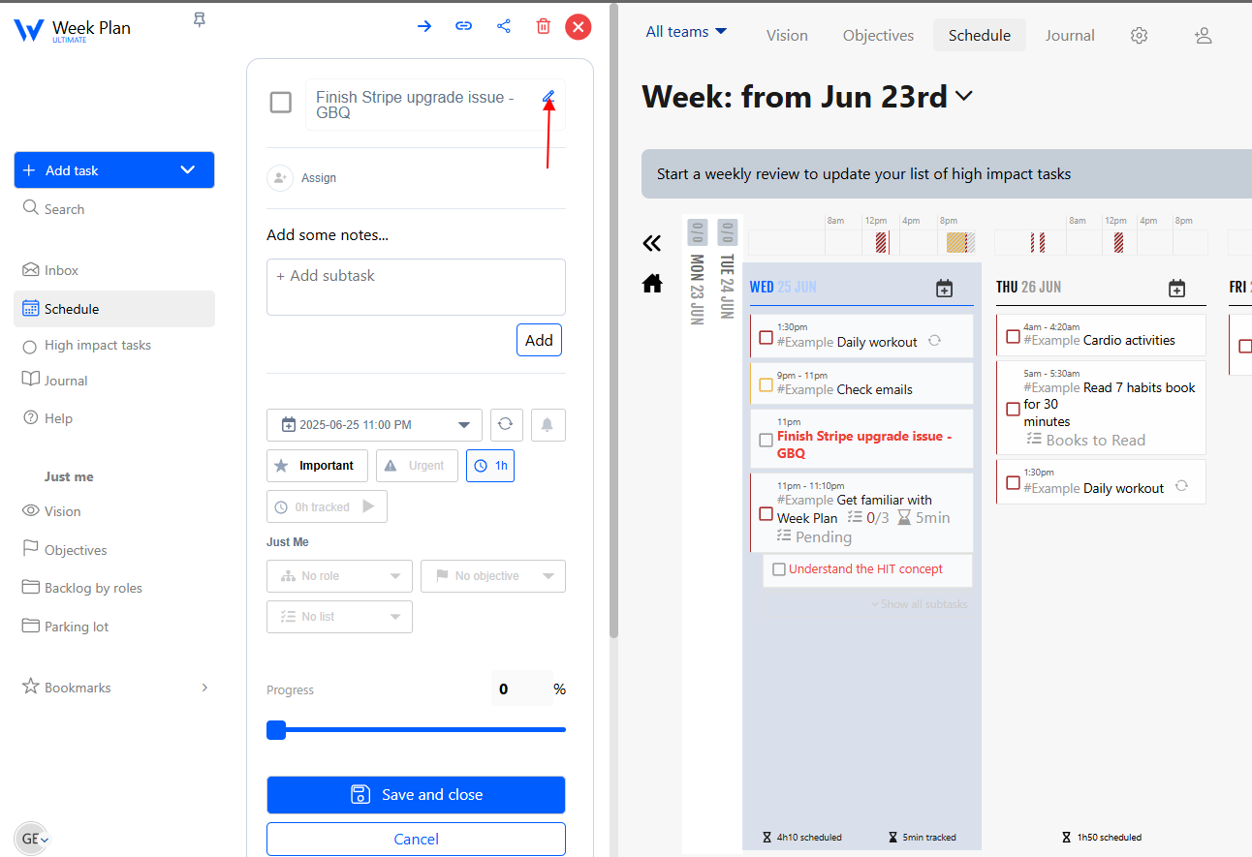

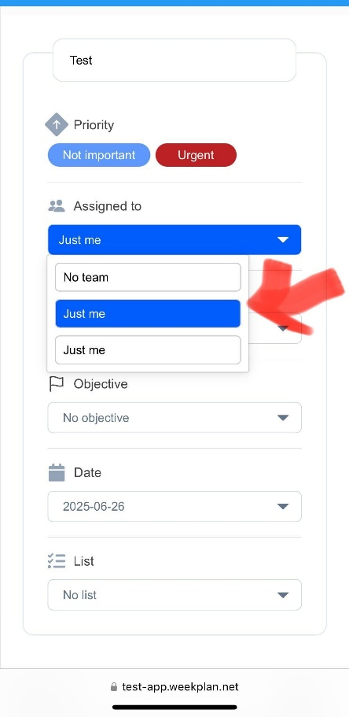

1. iPhone 12 Mini- Dropdown width not align with the box.
2. iPhone 12 Mini – Task text box cut from the top

